**MINISTRY OF EDUCATION AND TRAINING**

**FPT UNIVERSITY**

**DOCUMENT REPORT**

Capstone Project Document

**VN Habit Tracker**

|  |  |
| --- | --- |
| **Group 3** | |
| **Group members** | Lưu Thành Đạt - SE61124  Nguyễn Quang Tuyến - SE62069  Nguyễn Hữu Thắng - SE62447  Phạm Thanh Tùng - SE61628 |
| **Supervisor** | Lại Đức Hùng |
| **Ext. Supervisor** | N/A |
| **Capstone Project code** | VHT |

- Ho Chi Minh city, September 14th 2018

# Definitions, Acronyms, and Abbreviations

|  |  |
| --- | --- |
| **Name** | **Definition** |
| VHT | VN Habit Tracker |
|  |  |

# Software Requirement Specification

* + - 1. **User Requirement Specification**
  1. Guest Requirement

Guest is a person who doesn’t have access to the system. Guest can use some functions in the system. To use all functions, guest must login. These are some functions that guest can use:

• Login.

* Register.
  1. User Requirement

User is a guest who logged into the system with user’s role. There are some functions that user can use:

* Manage habit

+ View habit

+ Delete habit

+ Edit habit

+ Add habit

+ Check time habit

* Manage goal

+ Add goal

+ Delete goal

+ Edit goal

* Manage settings

+ Set goal

+ Set reminders

+ Set sound

+ Feedback and contact

* View statistics
* Logout
  1. Admin Requirement

Admin is the person who manages the system, a super user of system. There are some functions admin can use:

* Manage user

+ View user

+ Reset password

* Manage feedback

+ View feedback

+ Reply feedback

1. **System Requirement Specification**
   1. External Interface Requirement
      1. User Interface

* General requirement for graphics user interface is the GUI should be simple, clear, intuitive, and reminiscent.
* The interface design is an iterated process includes design, sketching and user assessment.
  + 1. Hardware Interface
* Smartphone, desktop, laptop or tablet has the ability to connect to the internet.
* The system will use the standard hardware and data communications resources of a standard computer.
  + 1. Software Interface
* Run with Chromes (v60 or above), Firefox (v46.1 or above)
* The screen must bigger than 1024x768.
* Mobile application: Android studio (version 3.1.4), Genymotion (version 2.12.2).
  + 1. Communication Protocol
* Using HTTP/HTTPS protocol.
  1. System Overview Use Case

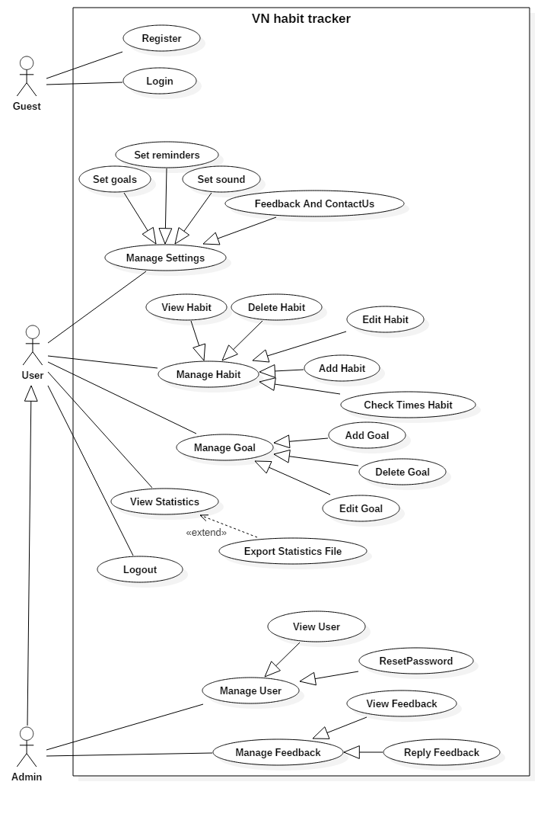

*Figure 2- System Overview Use Case*

* 1. List of Use case
     1. <User> Add habit

**Use Case Diagram**

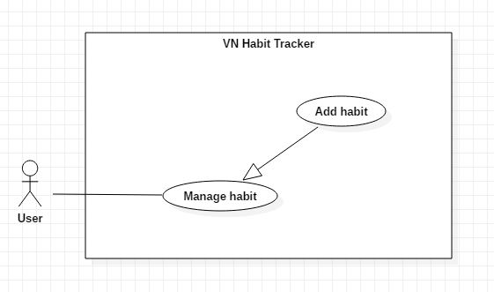

*Figure 3- <User> Add habit*

**Use Case Specification**

|  |  |  |  |
| --- | --- | --- | --- |
| **USE CASE – UC_01** | | | |
| **Use Case No.** | 01 | **Use Case Version** | 1.0 |
| **Use Case Name** | Add habit | | |
| **Author** | TuyenNQ | | |
| **Date** | 27/09/2018 | **Priority** | Normal |
| **Actor:**   * User   **Summary:**   * This use case allows the user to add a new habit.   **Goal:**   * Add a new habit from the schedule.   **Triggers:**   * User click on “Add habit” button.   **Preconditions:**   * Guest must login.   **Post Conditions:**   * **Success:** System shows “Successful to add a new habit!” message. * **Fail:** System shows “Failed to add a new habit!” message.   **Main Success Scenario:**   |  |  |  | | --- | --- | --- | | Step | Actor Action | System Response | | 1 | User click on “Add habit” button. | The system request information in form:   * Habit name: input text * Habit type: input text * Habit color: select button * Habit goal: select option * Set a target: datetime | | 2 | User click on “Save” button | - System shows “Add new habit success” message |   **Alternative:**   |  |  |  | | --- | --- | --- | | No | Actor Action | System Response | | 1 | User click on “Cancel” button. | - Close this form. |   **Exceptions:**   |  |  |  | | --- | --- | --- | | No | Cause | System Response | | 1 | User add an existed habit in the application | Show message to notify user this habit is existed. | | 2 | User add new fail | System shows “Add new habit failed!” message. |   **Relationships:**  N/A  **Business Rules:**   * The habit’s name must be under 255 characters and not null. * After adding habit success. The user returns menu list habit page. | | | |

*Table 13 – Add habit specification*

* + 1. <User> Archive habit

**Use Case Diagram**

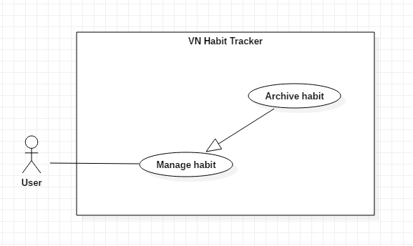

*Figure 4 - <User> Archive habit*

**Use Case Specification**

|  |  |  |  |
| --- | --- | --- | --- |
| **USE CASE – UC_02** | | | |
| **Use Case No.** | 02 | **Use Case Version** | 1.0 |
| **Use Case Name** | Archive habit | | |
| **Author** | TuyenNQ | | |
| **Date** | 27/09/2018 | **Priority** | Normal |
| **Actor:**   * User   **Summary:**   * This use case allows the user to delete habit.   **Goal:**   * Archive habit from the schedule.   **Triggers:**   * User click on “Archive habit” button.   **Preconditions:**   * Habit is existed.   **Post Conditions:**   * **Success:** System shows “Successful to archive!” message. * **Fail:** System shows “Failed to archive!” message.   **Main Success Scenario:**   |  |  |  | | --- | --- | --- | | Step | Actor Action | System Response | | 1 | User click on “Archive habit” button. | Shows a form to ask user want to delete habit. | | 2 | User click on “Yes” button | - That habit will be archived. |   **Alternative:**   |  |  |  | | --- | --- | --- | | No | Actor Action | System Response | | 1 | User click on “Cancel” button. | - Close this form. |   **Exceptions:**   |  |  |  | | --- | --- | --- | | No | Cause | System Response | | 1 | None of any habit was selected | Shows “Delete failed!” message. |   **Relationships:**  N/A  **Business Rules:**   * When a user archived a habit, this habit will be hidden. * The information of Habit is archived to the local. | | | |

*Table 14 – Archive habit specification*

* + 1. <User> Edit habit

**Use Case Diagram**

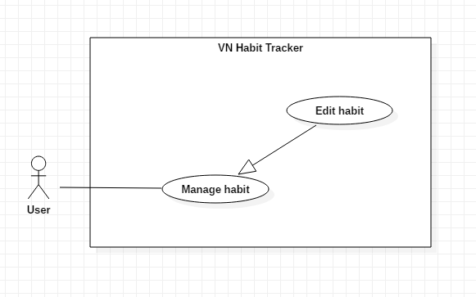

*Figure 5 - <User> Edit habit*

**Use Case Specification**

|  |  |  |  |
| --- | --- | --- | --- |
| **USE CASE – UC_04** | | | |
| **Use Case No.** | 03 | **Use Case Version** | 1.0 |
| **Use Case Name** | Edit habit | | |
| **Author** | TuyenNQ | | |
| **Date** | 27/09/2018 | **Priority** | Normal |
| **Actor:**   * User   **Summary:**   * This use case allows the user to edit a habit.   **Goal:**   * Edit habit when user input.   **Triggers:**   * User click on “Edit habit” button.   **Preconditions:**   * Guest must login. * The habit is existed.   **Post Conditions:**   * **Success:** System shows “Successful to edit!” message. * **Fail:** System shows “Failed to edit!” message.   **Main Success Scenario:**   |  |  |  | | --- | --- | --- | | Step | Actor Action | System Response | | 1 | User click on “Edit habit” button. | The system request information in form:   * Habit name: input text * Habit type: input text * Habit color: select button * Habit goal: select option * Set a target: datetime | | 2 | User click on “OK” button | - The system validates the information and shows confirmation message. | | 3 | User click on “YES” button | - System shows “Edit successfully!” message. |   **Alternative:**   |  |  |  | | --- | --- | --- | | No | Actor Action | System Response | | 1 | User click on “Cancel” button. | - Close this form. |   **Exceptions:**   |  |  |  | | --- | --- | --- | | No | Cause | System Response | | 1 | The field is blank | The system shows “Must not be blank!” message. | | 2 | System edit habit fail | System shows “Edit fail!” message. | |  |  |  |   **Relationships:**  N/A  **Business Rules:**   * The habit’s name must be under 255 characters and not null. * The information of Habit is sent to the server. * After Edit habit success. The user will return to the menu list habit page. | | | |

*Table 15 – Edit habit specification*

1. **Software System Attribute**
   1. Usability

* Provide a convenient way to interact with system.
* Screen layout and navigation are clear and easy to use.
* Interface are simple and clear UI, user can easy to manage habit and goal.
* Icons that indicate the actions should be easy to understand and users will not meet any troubles to recognize the feature of application.
  1. Reliability
* This application can run at the same time 100 users.
* The number of sending notification failure is 1 time per 200 notifications.
* The data should be backed up every day.
  1. Availability
* Website available 24/24.
* User connect internet to login.
* User use offline after login and connect internet to push data to the server.
  1. Security
* Private: Each role of user has a specific permission to interact with system.
* System always checks authorization and authenticated before doing function of user and admin.
* Only admin can manage user and feedback of user.
  1. Maintainability
* The code is easy to maintain and upgrade.
* Maintain the whole system every 1 months.
* Accidental problem will be resolved within acceptable time.
  1. Portability
* The website is running on Windows 7 or above.
* The mobile application running on device with API 23 or above.
  1. Performance
* All request is handling in maximum time of 5 seconds.

1. **Conceptual Diagram**